A
Research Report Proposal on
“Performance Analysis of Technology and FinTech Mutual Funds in India.”


Submitted to
Savitribai Phule Pune University
in Partial Fulfillment of the Requirement for the Award of the Degree of
MASTER OF BUSINESS ADMINISTRATION
By
Student Name: - Aayush Sahi
UID: - 2024-2707-0001-0011
Specialization: - Fintech
Under the Guidance of:
Dr. Suresh Kadam

MBA Fintech– Sem IV,
A.Y. 2025–26

Pune Institute of Business Management (PIBM)
(affiliated to Savitribai Phule Pune University)

13 March 2026
DECLARATION

I hereby declare that the project report titled “Performance Analysis of Technology and FinTech Mutual Funds in India.” submitted by me in partial fulfilment of the requirements for the award of MBA FinTech, under the guidance of ……………, is my original work and has not been submitted earlier, either partly or fully, for the award of any degree or diploma to any other university or institution.
This research work is a result of my own efforts, and all sources of information used have been duly acknowledged in the references section of the report.

Date: Signature of the Student
Place: Name: Aayush Sahi
Pune UID: 2024-2707-0001-0011

ACKNOWLEDGEMENT

I would like to express my sincere gratitude to all those who contributed to the successful completion of this research on A Study of Financial Awareness and credit card usage patterns Among youth. First and foremost, I extend my heartfelt
appreciation to my supervisor, Dr. ………………, for their invaluable guidance, encouragement, and constructive feedback throughout this study. Their insights and expertise have been instrumental in shaping the research and refining the analysis.
I am also grateful to Pune Institute of Business Management for providing the necessary resources and academic support that enabled me to conduct this research effectively. Special thanks to the faculty members for their assistance and motivation during this process. A sincere thank you to all who participated in the study by sharing their experiences and perspectives. Their responses provided valuable data and meaningful insights, making this research possible.
Additionally, I acknowledge the contributions of family and friends, whose continuous support, patience, and encouragement kept me motivated throughout this journey.
Lastly, I express my appreciation to all researchers and authors whose works have provided the foundation for this study. Their contributions to the field of banking fraud awareness have been invaluable.
Thank you all for your support and encouragement in making this research a reality

Name: Aayush Sahi
MBA – FinTech
Pune Institute of Business Management

Contents
1.Introduction 5
1.1 Statement of problem 6
1.2Purpose of this study 6
1.3 Research objectives 7
1.4 The theoretical framework 8
1.5 Significance of this project 9
Chapter II - Review of the Literature: 10
2.2 Research gap 13
2.3 Research Questions 13
2.4 Research Objective 14
2.5 Research Hypothesis 14
Chapter III Method: 15
3.1 Type of Research Design Used 16
3.2. Data Collection Method 16
3. Data Collection Instrument – Questionnaire Design 16
3.4 Scaling Techniques Used 16
3.5. Target Population of the Study 17
3.6. Sampling Frame 17
3.7. Sampling Unit 17
3.8. Sampling Method Used 17
3.9. Sample Size Determination 17
3.10. Data Analysis Techniques 17
3.11. Data Analysis Tools Used 17
Chapter IV – Data Collection and Analysis: 18
6. Annexures 37
6.1 Questioner 37
6.2 Observation Sheets 41
6.3 Field Maps 41
6.4 Geo-Tagged Photos 41
Bibliography 43

Executive Summary

The financial services industry has witnessed a lot of changes in the past few years due to the development of financial technology (FinTech) and the rapid development of technology. FinTech can be explained as the integration of technology and financial services to improve efficiency, accessibility, and innovation in financial transactions such as payments, lending, investment, and online banking. In India, the development of digital infrastructure, internet penetration, and the support of the government for digital payments have resulted in the rapid development of the FinTech industry. As a result, the financial industry is becoming more technology-driven, and new opportunities are emerging for investors and financial institutions.
On the other hand, the mutual fund industry in India has witnessed a lot of development in the past decade. Mutual funds allow investors to contribute money to a pool and invest in a diversified portfolio of securities managed by expert fund managers. With the increasing trend of sectoral and thematic mutual funds, investors can now invest in sectors that have demonstrated strong growth prospects. Among these, technology and FinTech-themed mutual funds have These mutual funds have also gained a lot of popularity due to the rapid growth of digital businesses and technology firms.
Technology mutual funds invest in companies that deal in information technology, software development, cloud computing, artificial intelligence, digital platforms, and technology-based financial services. Most of the technology mutual funds invest in companies that are directly or indirectly involved in the development of financial technology-based services. Therefore, technology mutual funds provide investors with an opportunity to invest in companies that benefit from digital evolution in the global economy.
The Indian economy has seen an incredible evolution in digital financial services in the past few years. Digital payment systems such as UPI, mobile wallets, and online banking have seen a significant rise. FinTech companies have also been playing an important role in the evolution of traditional financial services. They have made financial services faster, more accessible, and efficient. This has attracted the attention of investors who want to take advantage of the growth of technology and FinTech.

Even though technology and FinTech-themed mutual funds are becoming popular, still, many people are unaware of the performance of these mutual funds and the risks that are associated with investing in them. Sectoral mutual funds are considered to be highly risky compared to diversified mutual funds, as they are invested in one particular sector of the industry. Sectoral mutual funds can offer higher returns if the sector in which they are invested is performing well, but they can also be highly volatile if the sector in which they are invested is facing some economic issues. Hence, it is extremely important to understand the performance of technology and FinTech-themed mutual funds in order to understand the returns that can be generated by investing in these mutual funds.

The problem that this study aims to solve is the lack of understanding that many people have about the performance of technology and FinTech-themed mutual funds that are traded in the stock exchanges of India. Many people are eager to invest in the digital economy, but they are unaware of the performance, risks, and investment potential of technology and FinTech-themed mutual funds.
The major aim of this research is to assess the performance of the identified technology and FinTech themed mutual funds in India and compare their returns over a specific period of time. The research also aims to analyze the risk-return characteristics of the mutual funds and assess their overall performance. By conducting a systematic analysis of the identified mutual funds, this research tries to provide significant insights to investors and financial professionals.
The research methodology adopted for this research includes both primary and secondary methods of data collection. The secondary data is gathered from reliable financial sources such as AMFI India, Value Research Online, Moneycontrol, and the official websites of mutual funds. The data gathered is associated with the Net Asset Value (NAV), historical returns, and other performance indicators of the identified mutual funds. In addition to this, the primary data is gathered by using a structured questionnaire among investors to understand their awareness, perception, and investment behavior regarding technology and FinTech mutual funds. The gathered data is analyzed by using simple statistical methods such as percentage analysis, tables, and graphs.
The findings of this study are expected to contribute to valuable insights regarding the performance of technology and FinTech themed mutual funds in the Indian financial market. This research can also be helpful to investors in gaining knowledge regarding the opportunities and risks involved in technology-themed mutual fund investments. Additionally, financial advisors and asset management companies can also benefit from this research by gaining insights regarding investor perception of sectoral mutual fund investment.

In conclusion, this research aims to contribute to the knowledge of technology and FinTech mutual funds and their significance in the Indian financial market.

Introduction

  - Background of the Study

In the last few years, the financial sector has witnessed a significant amount of change due to the implementation of technology and digital innovation. The combination of technology and financial services has led to the emergence of a new word, known as ‘Financial Technology’ or ‘FinTech.’ FinTech refers to the use of technology to enhance financial services like payment, lending, investment management, and digital banking services. The growing use of smartphones, internet connectivity, and digital services has led to the increased adoption of FinTech services globally.
India has become one of the fastest-growing FinTech markets in the world. The country has witnessed a significant amount of growth in digital payments, mobile banking, online investment services, and digital lending services. The government has launched initiatives such as ‘Digital India’ and developed ‘Unified Payments Interface’ (UPI) to promote digital financial services. Therefore, technology-driven financial services have transformed the traditional financial sector, providing opportunities for investors and businesses alike.
Moreover, the mutual fund sector in India has witnessed a significant amount of growth in the last decade. It provides an opportunity for investors to invest in the portfolio of securities managed by professional fund managers. These funds collect money from various investors and invest it in different financial instruments like stocks, bonds, and money market instruments. Mutual funds are also regarded as a convenient investment opportunity because they provide diversification, expertise, liquidity, and lower investment costs compared to investing in the stock market directly.

Among mutual funds, sector funds and thematic funds are designed to invest in specific sectors or themes. Technology sector mutual funds are a type of sector mutual fund that invests in companies that belong to the technology sector. These companies may include software developers, digital platform companies, cloud computing companies, artificial intelligence companies, and technology-driven financial service companies. Since FinTech companies are highly dependent on technological infrastructure, technology mutual funds also include companies that contribute to the development of the FinTech sector in any way.
The technology sector has emerged as one of the most significant contributors to economic development in the digital economy. Companies belonging to the technology sector play a crucial role in facilitating the digital transformation of various sectors. Developments in cloud computing, artificial intelligence, big data analytics, cybersecurity, and digital platforms are changing the way businesses are carried out and financial services are delivered.
The rise of FinTech companies has also strengthened the relationship between the technology industry and financial services. FinTech companies use advanced technologies to provide efficient financial services such as digital payments, peer-to-peer lending, robo-advisory, and mobile banking platforms. These technologies have resulted in increased financial inclusion and have made financial services available to everyone.

1.2 Rationale and Relevance of the Study

The growing importance of technology and digital innovation has also garnered considerable interest from investors. Technology companies have proved to be potential investment avenues due to the growing need for digital services and technology-driven solutions. Hence, many asset management companies have come up with technology-driven mutual funds that allow investors to invest in the growing technology sector.
Technology and FinTech-themed mutual funds invest in companies that benefit from technology advancements and digital transformations. This type of mutual fund offers investors an opportunity to invest in high-growth segments like software services, digital platforms, cloud services, and financial technology infrastructure. However, as this type of mutual fund invests in a particular sector, it also entails higher levels of risk compared to other mutual funds.

Business and Management
The performance of technology and FinTech mutual funds is highly relevant from a business and management perspective. Investors need to know the performance of technology and FinTech mutual funds to assess the risk-return characteristics of technology-driven mutual funds before making investment decisions. By knowing the performance of technology-driven mutual funds, investors can understand whether technology-driven mutual funds can generate higher returns in the long run. For investors, it is necessary to have information about the risk-return profiles of such funds before making an investment decision. Knowledge about the performance of such funds will enable investors to make an assessment about whether technology-based investments are capable of yielding consistent results in the long run.

Investor awareness and perception about technology-based investments also have a significant influence on investment behavior. With the increasing use of FinTech applications and online investment platforms, investors are becoming increasingly interested in technology-based financial investments. However, investors may not be aware of the risks associated with sectoral mutual funds. Hence, understanding investor perception about technology and FinTech mutual funds can offer significant insights into investment behavior.

1.3 Current Trends in Technology and FinTech Investments

The global economy is slowly moving towards a digital economy, and technology companies are leading this transformation. In India, the adoption of digital payment systems and online financial services has grown significantly in recent years. Online services for digital wallets, mobile banking services, online trading services, and financial advisory services are becoming increasingly popular among people and organizations. Technologies such as AI, blockchain, cloud computing, and data analytics have created new opportunities for financial innovation. FinTech companies are using these technologies to create new financial products that are more efficient, cost-effective, and customer-centric.
As the digital economy is on the rise, mutual funds related to the technology sector are gaining popularity among investors who want to invest in the opportunities being created by technology companies. However, technology companies are also volatile due to the changing market conditions, competition, and government regulations. Hence, it is important to evaluate the performance of technology and FinTech mutual funds to understand their potential for investment.

1.4 Statement of the Problem

Although the technology and FinTech sector has shown potential for high growth, it has been noticed that the investors lack a proper understanding of the performance and risk associated with technology mutual funds. Sectoral mutual funds tend to show higher returns in the market with high sectoral growth, but they also involve higher risk due to poor diversification.
Most of the investors tend to invest in mutual funds based on their past performance or market trends without carrying out a detailed analysis of the performance of mutual funds, including their consistency of returns and risk measures. Therefore, it is the need of the hour to analyze the performance of the selected technology and FinTech mutual funds.
The purpose of this research work is to examine the performance of the selected technology and FinTech mutual funds in India.

Research Objectives

- To examine the performance of the chosen Technology and FinTech themed mutual funds in India.
- To compare the returns of the chosen technology sector mutual funds over a period of time.
- To assess the risk-return profile of the chosen mutual funds.
- To investigate the awareness and perception of investors about Technology and FinTech mutual funds.
- To offer suggestions to investors based on the performance analysis of technology sector mutual funds.

CHAPTER 2

REVIEW OF LITERATURE

2.1 Introduction
The rapid evolution of financial markets, combined with technological advancements, has significantly influenced investment patterns and mutual fund performance. The emergence of Financial Technology (FinTech) has transformed how investors access, analyze, and invest in mutual funds. This section reviews existing literature on mutual fund performance, the impact of technology and FinTech on investment behavior, and the growing relevance of digital platforms in financial decision-making.

2.2 Research Gap
Despite extensive research on mutual fund performance and the growing influence of FinTech, several gaps remain:
• Most studies focus on general mutual fund performance, with limited emphasis on Technology and FinTech themed funds specifically
• Existing research often analyzes returns or risk separately, rather than providing a combined risk-return evaluation in a FinTech context
• Limited studies integrate mutual fund performance with FinTech ecosystem growth (UPI, digital platforms, AI)
• There is insufficient research on investor perception towards FinTech-based mutual fund investments in India
• Few studies combine performance analysis and behavioral analysis (survey-based approach)

2.3 Thematic Discussion

2.3.1 Mutual Fund Performance Evaluation
Several studies emphasize the importance of performance evaluation metrics such as return, risk, and risk-adjusted measures. Kumar et al. (2022) highlighted that traditional measures like returns alone are insufficient, and tools such as the Sharpe ratio provide better insight into fund performance. Sharma and Gupta (2023) observed that sectoral mutual funds, including technology funds, tend to outperform during periods of sector-specific growth but are subject to higher volatility due to lack of diversification.
Rao and Iyer (2023) further supported this by stating that sector concentration increases systematic risk, making performance evaluation more complex. These findings indicate that analyzing technology and FinTech mutual funds requires a balanced approach considering both return potential and risk exposure.

2.3.2 Impact of Technology and FinTech on Mutual Funds
The emergence of FinTech has significantly transformed the mutual fund industry. Singh (2023) found that FinTech platforms have increased accessibility and participation among retail investors. Similarly, Verma (2024) highlighted the role of mobile applications and digital platforms in simplifying investment processes, leading to higher inflows into mutual funds. Kapoor (2023) emphasized that the growth of digital payment systems such as UPI has strengthened the FinTech ecosystem, indirectly boosting investments in technology-driven companies. Das (2022) further observed that companies involved in artificial intelligence and digital innovation contribute positively to the performance of technology mutual funds.
These studies collectively indicate that FinTech is not only influencing investor behavior but also enhancing the performance potential of technology sector funds.

2.3.3 Investor Behavior in Digital Investment Ecosystem

Investor behavior has evolved significantly with the rise of digital platforms. Mehta and Jain (2022) found that investors prefer online platforms due to convenience, transparency, and ease of access. Nair (2024) highlighted that while awareness of mutual funds is increasing, understanding of sectoral funds remains limited among retail investors.
Patel and Shah (2024) observed that investors are increasingly attracted to technology funds due to their high growth potential, especially during periods of digital expansion. However, many investors tend to overlook the associated risks, focusing primarily on returns.
This suggests that investor perception plays a crucial role in investment decisions related to FinTech and technology mutual funds.
2.4 Research Gap
Despite extensive research on mutual fund performance and the growing influence of FinTech, several gaps remain:
• Most studies focus on general mutual fund performance, with limited emphasis on Technology and FinTech themed funds specifically
• Existing research often analyzes returns or risk separately, rather than providing a combined risk-return evaluation in a FinTech context
• Limited studies integrate mutual fund performance with FinTech ecosystem growth (UPI, digital platforms, AI)
• There is insufficient research on investor perception towards FinTech-based mutual fund investments in India
• Few studies combine performance analysis and behavioral analysis (survey-based approach).

2.4 Literature Review Table

Author(s) | Year | Study Focus | Key Findings
Sharma & Gupta | 2023 | Mutual Fund Performance | Found that sectoral funds outperform diversified funds during sector growth phases but show higher volatility
Kumar et al. | 2022 | Risk-Return Analysis | Identified Sharpe ratio as a strong indicator for evaluating mutual fund performance
Patel & Shah | 2024 | Technology Funds | Technology funds showed superior returns during digital expansion periods
Singh | 2023 | FinTech Growth | FinTech adoption increased retail participation in mutual funds
Mehta & Jain | 2022 | Investor Behavior | Investors prefer digital platforms for ease and accessibility
Verma | 2024 | Digital Investment Trends | Rise in mobile-based investing significantly impacts fund inflows
Rao & Iyer | 2023 | Sectoral Fund Risk | Sector funds carry higher systematic risk due to concentration
Das | 2022 | AI & Finance | AI-driven companies positively influence fund performance
Kapoor | 2023 | FinTech Ecosystem | Growth of UPI and digital payments boosts fintech-related investments
Nair | 2024 | Mutual Fund Awareness | Investor awareness is increasing but still limited in sectoral funds

2.5 Conclusion of Literature Review

The review of literature indicates that technology and FinTech have become significant drivers of mutual fund investment and performance. While sectoral funds offer high return potential, they are associated with higher risk due to sector concentration. The rise of FinTech platforms has increased investor participation and accessibility, transforming traditional investment behavior.
However, there remains a need for a comprehensive study that integrates performance evaluation of technology mutual funds with investor perception and the broader FinTech ecosystem. This study aims to address these gaps by providing a detailed analysis of selected Technology and FinTech themed mutual funds in India.

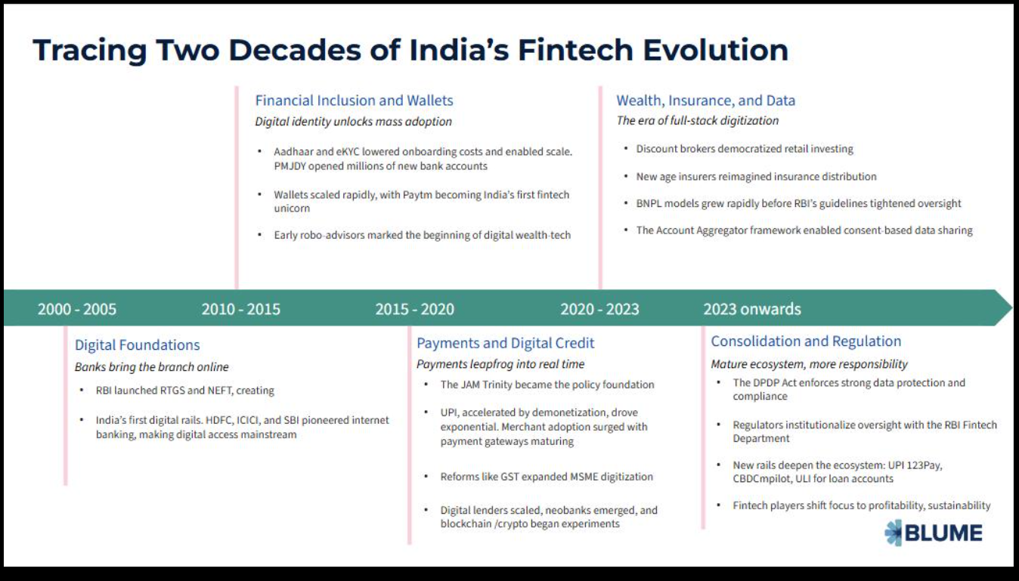
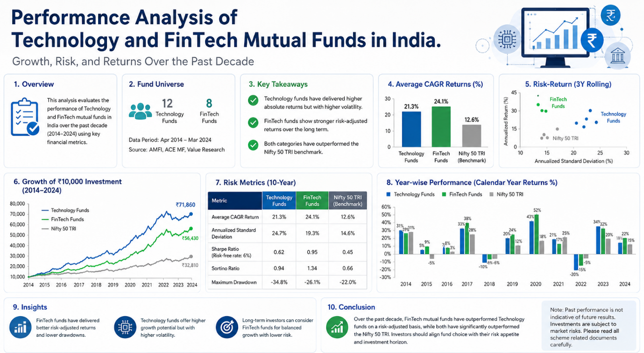
CHAPTER – 3
RESEARCH METHODOLOGY

3.1 Introduction
This study employs a descriptive research design. The primary focus is to analyze and interpret patterns, behaviors, and relationships regarding financial awareness and credit card usage among youth. Descriptive research is ideal for summarizing the current state of financial literacy, usage behaviors, and influential factors, thereby offering insights into areas that require policy intervention or educational reforms. Research methodology can be termed as the method through which data can be collected, analyzed, and interpreted with the aim of fulfilling the aim of the study. Research methodology gives direction to the study in which it enables researchers to undertake research in a systematic and scientific manner. In the present study, performance of the chosen technology and FinTech themed mutual funds will be evaluated alongside the perception held by investors concerning such investment opportunities. and procedures followed to collect, analyze, and interpret the data collected to reach the purpose of the research.
The current research paper is devoted to the analysis of performance of selected Technology and FinTech thematic mutual funds along with the perception of investors regarding such investment schemes. The study incorporates financial analysis as well as behavioral analysis to obtain an overall view of technology and fintech mutual funds in the Indian financial market. Various methodologies are employed for this research paper including descriptive as well as analytical. Primary and secondary sources of information will be utilized to assess the performance of mutual funds and investment behavior of investors regarding technology and FinTech mutual funds.

3.2 Research Design

The methodology involved in the study is Descriptive and Analytical research designs.
Research design provides the overall framework for conducting the study in a systematic manner. It acts as a blueprint for data collection, measurement, and analysis.
The present study adopts both-
Descriptive Research Design and Analytical Research Design.
Descriptive Research
Descriptive research is used to understand and describe investor behavior, awareness, and perception regarding Technology and FinTech themed mutual funds. It helps in identifying patterns related to investment preferences, risk tolerance, awareness levels, and investor attitudes toward technology-oriented investment products.
Analytical Research
Analytical research is used to evaluate the actual performance of selected mutual funds by analyzing returns, risk factors, and comparative performance indicators. This approach helps in understanding the effectiveness and growth potential of Technology and FinTech themed mutual funds.
The combination of descriptive and analytical research enables the study to cover both quantitative financial performance and qualitative investor perception.

3.3 Objectives of the Study

The main objective of the study is:
To study and analyze the performance of selected Technology and FinTech themed mutual funds in India.
The rapid growth of digital technologies and FinTech innovations has significantly transformed the financial services industry. Technology-driven companies involved in digital payments, cloud computing, artificial intelligence, blockchain, and financial platforms are becoming increasingly important in the modern economy. Aayush sahi a result, Technology and FinTech themed mutual funds have gained popularity among investors seeking exposure to high-growth sectors.

However, despite increasing investor interest, there is limited understanding regarding the actual performance, risk level, and long-term investment potential of these sectoral mutual funds. Technology-focused funds often experience higher volatility due to sector concentration and market fluctuations. Moreover, many investors are influenced by market trends and digital hype without conducting proper analysis of returns and risk-adjusted performance.

Primary Objective
• To study and analyze the performance of selected Technology and FinTech themed mutual funds in India.

Secondary Objectives
• To compare the returns of selected Technology and FinTech mutual funds over a specific period.
• To evaluate the risk-return relationship of the selected mutual funds.
• To understand investor awareness and perception regarding FinTech mutual funds.
• To identify factors influencing investment decisions in Technology and FinTech themed mutual funds.
• To provide suggestions based on the findings of the study.

3.4 Data Typ

This research is based on Primary Data and Secondary Data.
Primary Data
Primary data is collected by investors using a well-structured questionnaire to know about their awareness, perception, investment choices and views on Technology and FinTech mutual funds.

Secondary Data
Secondary data is collected from reliable sources like:
• AMFI India
• Value Research Online
• Moneycontrol
• Websites of Mutual Fund Schemes
• Research Papers/Articles

Information related to Net Asset Value (NAV), returns, risk factors, fund performance, etc. is collected through secondary data.

3.5 Data Collection Methods.
The study utilizes both online and offline survey methods to gather primary data directly from the target population. The survey ensures a standardized approach to capturing diverse financial behaviors, enabling comprehensive analysis. Participants voluntarily provide responses to structured questions that cover various aspects of financial literacy and credit card usage.
Survey Method-
Primary data collection involves the use of the survey method, where a questionnaire is used to know investor awareness, risk perception, return expectations, and investment views on technology and FinTech mutual funds.

Secondary Data Collection
Secondary data about selected mutual fund schemes is collected from reliable sources for performance analysis purposes.

3.6 Sampling Method.

In this study, we adopt the convenience sampling method. Respondents selected on the basis of ease of availability. The research study is confined to select themes of Technology and FinTech mutual funds available in India. This study will consider assessing the performance of these funds considering return and risk measures within a stipulated time frame.

The research will also be conducted to determine investor awareness, perception, and behavioral factors related to FinTech mutual funds. Respondents chosen for this study will have an understanding about investing in mutual funds and digital financial tools.

Major areas considered in this study are:

• Assessment of performance of select mutual funds
• Risk-return measures
• Investor awareness/perception
• Technological development in mutual fund investments
• FinTech-driven investment practices in India
The time frame of the study is five years, i.e., from 2020 to 2025.

3.7 Sample Size.
The proposed sample size for the study will be between 100 respondents.
The proposed sample size would be ideal for analyzing the perceptions of the investors along with some statistical analysis in relation to the objectives of research.
The study uses both Primary Data and Secondary Data.
Primary Data
Primary data refers to original data collected directly from respondents for the specific purpose of the research. In this study, primary data is collected through a structured questionnaire distributed among investors and individuals aware of mutual fund investments.
Secondary Data
Secondary data refers to data that has already been published or collected by other organizations. Secondary data for this study is collected from:
• AMFI India
• Value Research Online
• Moneycontrol
• Official mutual fund websites
• Financial journals and research articles
• Published reports and market studies
Secondary data includes NAV values, returns, performance indicators, risk measures, and historical fund information.
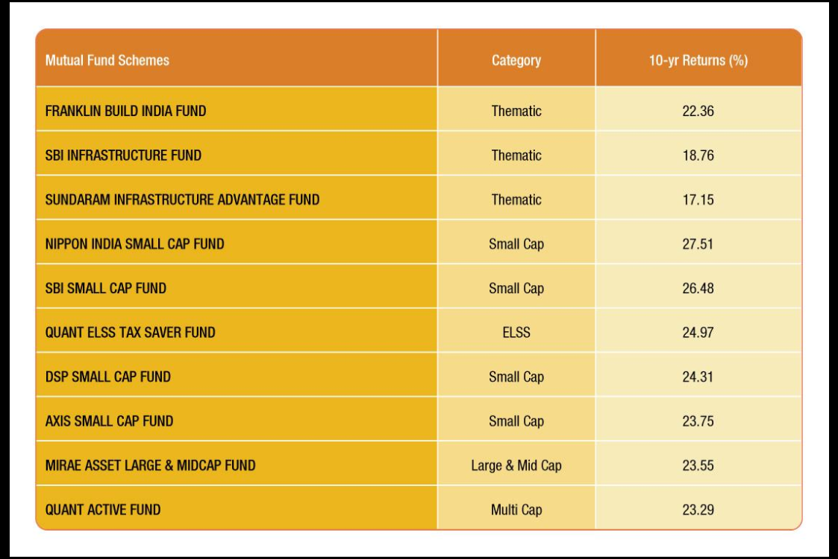

3.8 Selection of Mutual Funds

The selected funds are aayush sahi follows:
Selected Technology and FinTech Mutual Funds

- SBI Technology Opportunities Fund – Direct Plan – Growth
- ICICI Prudential Technology Fund – Direct Plan – Growth
- Tata Digital India Fund – Direct Plan – Growth
- Aditya Birla Sun Life Digital India Fund – Direct Plan – Growth
- Invesco India Technology Fund – Direct Plan – Growth

The above-selected mutual funds are those which have a direct link with the technology sector and market.

3.9 Period of Study

The period of time chosen for this study is from 2020 to 2025, and this span has been chosen since the period under review indicates the rapid growth in the technological advancement and FinTech usage in India.
The study adopts the Convenience Sampling Method. Under this method, respondents are selected based on accessibility and availability. This method is considered suitable due to time limitations and ease of collecting responses from individuals familiar with mutual fund investments.
The respondents include:
• Students
• Salaried employees
• Business professionals
• Individual investors

3.10 Tools and Techniques Used for Analysis

The following tools and techniques are used for analyzing the gathered data:
Primary Data Analysis-

• Percentage Analysis
• Pie charts
• Graphical Representation

Secondary Data Analysis

• Return analysis
• Standard Deviation
• Sharpe Ratio
• Comparative Performance Analysis

MS Excel is being used for organizing and presenting data graphically.

3.11 Hypothesis of the Study

Null Hypothesis (H0)
There is no significant correlation between the development of the technology and FinTech industries and the performance of technology and FinTech themed mutual funds in India.

Alternative Hypothesis (H1)
There is a significant correlation between the development of the technology and FinTech industries and the performance of technology and FinTech themed mutual funds in India.

3.12 Scope of the Study

This study shall be conducted on selected Technology and FinTech themed mutual funds in India. They shall be assessed in terms of performance using return and risk variables, and the attitude of investors towards investment in such mutual funds shall be investigated. This study will be conducted only on selected funds and respondents within the defined sample size and timeframe.
3.1 Target Population of the Study
The target population includes individuals aged 18–30 years, primarily students, young professionals, and entrepreneurs. These individuals are likely to be active participants in financial decision-making and represent varying levels of financial literacy.
3.2. Sampling Frame
The sampling frame consists of respondents from urban and semi-urban settings who are accessible via online platforms, colleges, workshops, and offline community outreach programs. This ensures diversity in financial behaviors and literacy levels across different socioeconomic backgrounds.
3.3. Sampling Unit
The sampling unit is an individual respondent who meets the eligibility criteria, such as owning a credit card or being actively involved in financial decision-making.
3.4. Sampling Method Used
A random sampling technique is used, with stratification based on demographic factors such as age, gender, and education. This approach ensures unbiased representation and captures data from varied subgroups within the target population.
3.5 Data Analysis Techniques
The study employs a combination of descriptive and inferential statistical techniques, such as:
Descriptive Analysis: Calculating frequencies, percentages, and averages to summarize demographic details, confidence levels, and behaviors.
Inferential Analysis: Conducting chi-square tests to evaluate relationships (e.g., between financial education and repayment difficulties or between gender and credit card ownership).
These techniques help uncover patterns and associations within the data.

3.13 Limitations of the Study

- This study will only cover selected Technology and FinTech themed mutual funds.
- The sample size for this research will be small and might not represent the opinion of all investors.
- This study will depend on secondary data that was collected from the Internet and financial reports.
- Market and economic conditions could affect the mutual fund’s performance during the period of study.
- Responses given by the investors would be subjective.

3.14 Ethical Considerations

The study ensures that all information collected from respondents remains confidential and is used strictly for academic purposes only. Participation in the survey is voluntary, and respondents are not forced to disclose personal or sensitive information.
The research also ensures proper acknowledgment of secondary data sources and follows academic integrity standards while preparing the study.
The data is analyzed using SPSS and Excel for:
- Calculating statistical measures, including frequencies and chi-square values.
- Creating charts and graphs (e.g., clustered bar charts, pie charts) to visualize trends and comparisons.

3.15 Data Collection Instrument – Questionnaire Design
The primary data collection instrument is a structured questionnaire. The questionnaire includes:
Demographic Details: Age, gender, and education level.
Behavioral Information: Credit card ownership, usage frequency, primary purposes, and repayment habits.
Confidence and Challenges: Confidence in personal finance management and challenges faced in repaying credit card debt.
External Influences: The role of peer influence, family guidance, advertising, and social media in financial decisions.
Open-Ended Questions: Suggestions for improving financial education among youth.
Scaling Techniques Used in the project work
The research utilized the following scaling methods:
Likert Scale (5-point): For measuring how much respondents agree with convenience, trust, satisfaction, and decision-making behavior statements (e.g., Strongly Disagree to Strongly Agree)
Ordinal Scale: Apply in rating questions to measure the perceived effect of various factors like offers, delivery speed, and return policy (e.g., Very Low to Very High).
Nominal Scale: Used in questions where respondents might pick more than one relevant response (e.g., "What would make you switch from one quick commerce platform to another for personal care products?"). This enabled capturing a variety of influencing factors and consumer motivations.

3.15 Conclusion
The research methodology provides a structured framework for conducting the study on Technology and FinTech themed mutual funds in India. By combining primary and secondary data along with descriptive and analytical approaches, the study aims to evaluate both fund performance and investor perception. The methodology adopted is appropriate for achieving the objectives of the research and generating meaningful findings related to Technology and FinTech mutual fund investments in India.

Chapter – 4

CHAPTER 5
FINDINGS, DISCUSSION AND CONCLUSION

5.1 Introduction
The scope of this study will be limited to specific technology and FinTech mutual funds that operate in India. In addition to studying the performance of these selected mutual funds, the research will look into the level of investor awareness, perception, and behavior in relation to investing in FinTech mutual funds. The respondents considered in the study are those who have a basic understanding of mutual funds and digital finance platforms.
Main areas of focus include:

• Performance analysis of selected mutual funds
• Analysis of risks and returns of mutual funds
• Awareness and perception levels of investors
• Effects of advancements in technology on mutual funds
• Investment trends within FinTech in India

The timeframe for the study is five years, from 2020 to 2025.

5.2 Key Findings from the Study

The following major findings were noted based on the analysis of primary and secondary data:

- There is increasing attention from investors in technology and FinTech-related mutual funds, mainly because of the fast-paced digital revolution in the technological space.

- Awareness of technology and FinTech mutual funds is fairly high among the sample respondents, who viewed them as high-growth investment opportunities.

- The major reason why the respondents chose the technology and FinTech mutual funds was long-term wealth creation and return potential.

- Technology and FinTech mutual funds provide good return potential during times of growth in technological and digital innovations.

- Technological innovation, digital payment methods, and advances in AI and cloud computing were some of the factors mentioned by respondents as drivers of the performance of these funds.

- Technology and FinTech mutual funds were viewed as medium-to-high-risk investment products by most respondents.

- Global technological developments were viewed as a critical factor in deciding on investments in FinTech mutual funds by many respondents.

- The risk-adjusted performance measures for the selected mutual funds varied based on their Sharpe ratios.

- There seems to be increased investor confidence in FinTech-based investments owing to advancements in digital financial services.

5.3 Discussion of Findings

The findings from this study reveal that the rise of technologies plays an important role in the popularity of the Technology and FinTech themed mutual funds. Digital services, including online finance applications, artificial intelligence, and digital payments, positively impact investors' decision making concerning the choice of technology-focused investments. Moreover, the findings of the study are in line with prior research that states that technology mutual funds offer great opportunities for growth and investments during the period of rapid digitalization but tend to be volatile due to their single-sector focus.
According to the analysis of perceptions held by the respondents, most people are familiar with the concept of Technology and FinTech mutual funds and are aware of their significant growth opportunities. The results demonstrate that the development of digital literacy and access to online financial platforms facilitate the use of sectoral funds by investors.
The findings are similar to other sources stating that innovations, technologies such as cloud computing, and the digitalization of the financial landscape affect the performance of mutual funds investing in the technology sector.
On the other hand, the findings emphasize the need for investors to perceive these types of mutual funds as risky. At the same time, the study highlights that investors remain cautious regarding the risk associated with these funds. Since sectoral funds are affected by industry-specific fluctuations, investors generally prefer them for long-term investment horizons rather than short-term gains.

5.4 Conclusion

From the study, it is noted that technology and FinTech-themed mutual funds have gained importance as viable sources of investment in the Indian financial market due to technological development and digitalization. Such mutual funds allow investors to invest in sectors that exhibit high growth potential, which includes the likes of artificial intelligence, cloud computing, digital payments, and financial technology services. From the results, it is observed that certain selected Technology and FinTech mutual funds show promise with regards to their returns, particularly during times when there is digitalization and technological advancement in the market. Nevertheless, the findings also indicate that such mutual funds exhibit relatively higher risks since they focus on certain sectors.
From the analysis of perceptions, it was observed that the awareness and acceptance of FinTech investments are increasing amongst investors. As investors make use of digital channels for investment, their involvement in Technology and FinTech mutual funds becomes increasingly likely.
In summary, the study reveals that Technology and FinTech themed mutual funds can be considered as good investments for investors willing to take more risks and invest in the long run.

5.5 Recommendations

Based on the findings of the study, the following recommendations are suggested:
• Investors should evaluate both returns and risk before investing in Technology and FinTech mutual funds.
• Long-term investment strategies should be preferred for sectoral funds due to short-term market volatility.
• Investors should diversify their portfolio instead of depending entirely on a single sector.
• Asset management companies should increase investor awareness regarding the risks and benefits of FinTech mutual funds.
• Financial literacy initiatives should focus on educating investors about digital investment products and risk-adjusted performance analysis.
• Investors should regularly monitor market trends, technological developments, and economic conditions before making investment decisions.

5.6 Limitations of the Study

• The study considers Technology and FinTech theme mutual funds only.

• The number of samples selected is not necessarily a representation of the sentiments of all the investors in India.

• The study considers both primary and secondary sources of information available in financial websites and journals.

• Any changes in the market may affect the performance of the mutual funds.

• The reaction of the investor may depend on their personal feelings and opinions.

5.7 Scope for Future Research

• Future studies may include a larger number of samples.

• Future studies may compare the performance of Technology mutual funds with diversified equity mutual funds.

• Future researchers may analyze the role of artificial intelligence and blockchain technology in enhancing mutual fund performances.

• Future studies may compare international technology and FinTech theme mutual funds.

• Future researchers may employ complex statistical and financial models.

